Assessment: Lab 9

Student Name: Adam Di Cioccio

Lab Professor Name: Mohammad Patoary

Lab Section Number: 321

Due Date: December 4, 2020

# Pseudocode

Import java.util.scanner

Create scanner

Declare double userInput

Declare the array

Set array size

For loop (repeat for length of array)

Ask user for input

Insert input

Set value into array at index

For loop (repeat from end of array to beginning)

Display output at index

Close scanner

Print name

# Flowchart

Start

Declare double userInput and array newArray

Set array length to [5]

For loop (newArray.length)

Prompt user

Get user input and set into the index of array

End for loop

For loop (arraylength end to beginning

Display value at index

End for loop

Display name

Close scanner

Stop

# Hand trace

|  |  |  |  |  |
| --- | --- | --- | --- | --- |
| Loop | Loop continues? | Console output | Input Value | Index |
| 1 | Y | Enter Number 1: | 1.1 | 0 |
| 2 | y | Enter Number 2: | 2.2 | 1 |
| 3 | y | Enter Number 3: | 3.3 | 2 |
| 4 | y | Enter Number 4: | 4.4 | 3 |
| 5 | n | Enter Number 5: | 5.5 | 4 |

|  |  |  |  |
| --- | --- | --- | --- |
| Loop | Loop continues? | Output | Index |
| 5 | Y | Number 5 is 5.5 | 4 |
| 4 | Y | Number 4 is 4.4 | 3 |
| 3 | Y | Number 3 is 3.3 | 2 |
| 2 | Y | Number 2 is 2.2 | 1 |
| 1 | N | Number 1 is 1.1 | 0 |

# Memory map

Arrays

<<Arrays>>

index

Arrays

5

Ref

Creating the array

Double[]

|  |  |  |  |  |
| --- | --- | --- | --- | --- |
| 0.0 | 0.0 | 0.0 | 0.0 | 0.0 |
| [0] | [1] | [2] | [3] | [4] |

newArray

Ref

After loops

Double[]

|  |  |  |  |  |
| --- | --- | --- | --- | --- |
| 1.1 | 2.2 | 3.3 | 4.4 | 5.5 |
| [0] | [1] | [2] | [3] | [4] |

newArray

Ref

# Java screenshot

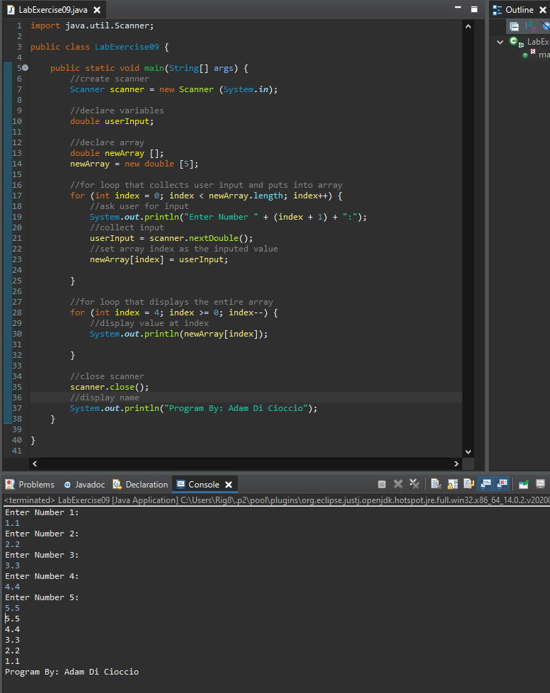

# References / Sources Cited